**GOOGLE BUSINESS PROFILE: FUNDAMENTALS**

Fact Sheet for Businesses

Brought to you by

**Table of Contents**

**Accessing Google Business Profiles Page 2**

**Profile Completeness Page 5**

**Listings for Service Area Businesses Page 7**

**Reviews Management & Best Practices Page 9**

**Photo Management & Best Practices Page 12**

**How to Use Posts in Google Business Profiles Page 14**

**Take your Google Business Profile to the next level with Locl Page 16**

**Accessing Google Business Profiles**

Google Business Profiles are free, easy-to-use tools for businesses and organizations to manage their online presence across Google’s products, including Search and Maps. Google Business Profiles are the only way you can control the information that appears about your business on Google.

There are 5 business types that use Google Business Profiles:

1. Storefront Location
2. Service Area Business (you serve customers but do not have a public location)
3. Hybrid Business (storefront address and a designated service area)
4. Individual practitioners (public-facing professional)
5. Departments or businesses within another business (e.g. universities, medical facilities, government offices and restaurants within hotels).

SIGNING IN OR SIGNING UP

You will need a valid Google account to begin, and the account you choose will become the “owner” of your business within Google’s products. Any @gmail.com account will work, or you may set up an account using your own email address. To create a Google account, follow this link: <https://accounts.google.com/SignUp>. Note that you can switch to using an existing email address with the link directly below the “choose your username” field. 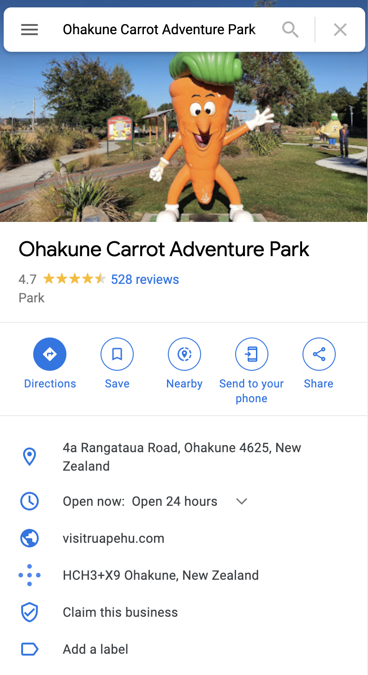

VERIFYING YOUR BUSINESS

Once you’ve logged into your Google account, you’ll need to verify your business. Verification is a security measure that Google uses to ensure that the people managing a business’ information are the actual owners.

If your business has a listing on Google already, search for your business on maps.google.com or within the maps app on your phone. Look for the “Claim this business” icon in your business profile, typically below your website address:

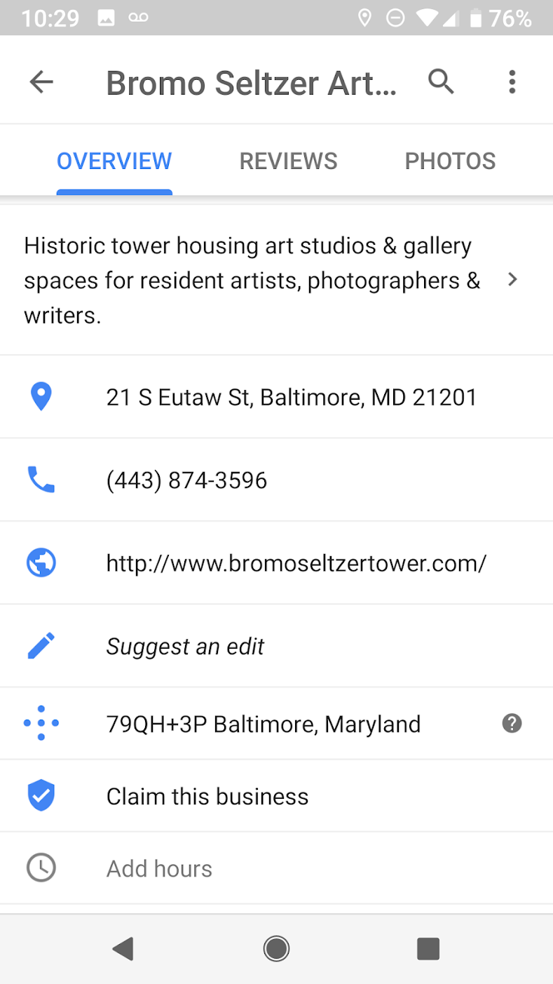

If you see this icon and text, your business profile is unverified and you should complete the following steps to verify you are the rightful manager for the profile. Note that you **must use the maps product** to determine if your business is verified already, using the regular [www.google.com](http://www.google.com) search will not produce an accurate result. 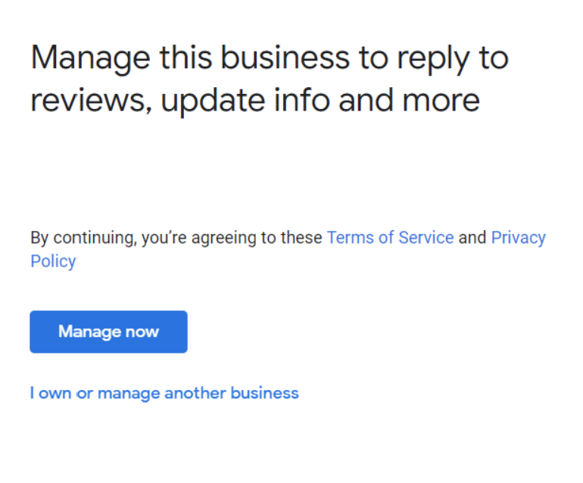

Clicking the “Claim this business” link will take you to the confirmation screen similar to the screen shot to the right. Click the “Manage now” button and proceed through the steps of the process. You can skip adding or editing any of your information as you can access this after your verification steps. Note: **do not make changes to your business name, address or phone number at this stage** - doing so may complicate your verification.

At the end of the process you’ll be given options to verify based on how long your profile has been active and the continuity of information about your business (see NAP section below.) Verification options can include “by phone,” “by text” and “by email” which send a confirmation code to the contact information listed. In some cases, these options may not be available to you and you will have to use the “by mail” option which sends a postcard with the confirmation code to your listed address.

You won’t be able to control or access many of the features of the Google Business Profile dashboard until you are verified.

ACCESSING YOUR BUSINESS INFO

Once you’ve set up your Google account and claimed your business, you can edit your business information in three places. The first is within the Search Engine Results Page (SERP.) To edit your listing through the SERP simply perform a search for your business name at [www.google.com](http://www.google.com). When you are logged in with a verified account and your business profile is shown on the right side of the screen you will see a block of information at the top of the page that looks similar to this:

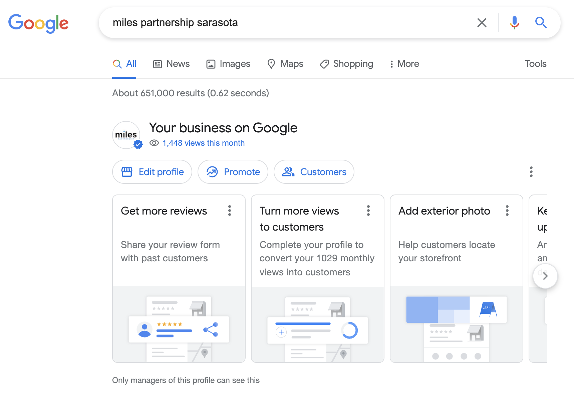

Note that only verified managers of the profile shown will see this action block on the search results page - people searching for your business on Google won’t see these options.

Secondly, you can access and edit your business profile through the maps app on your phone, click the icon for your profile in the upper right hand corner and select “Your Business Profile(s)” from the menu that appears. See example images below:

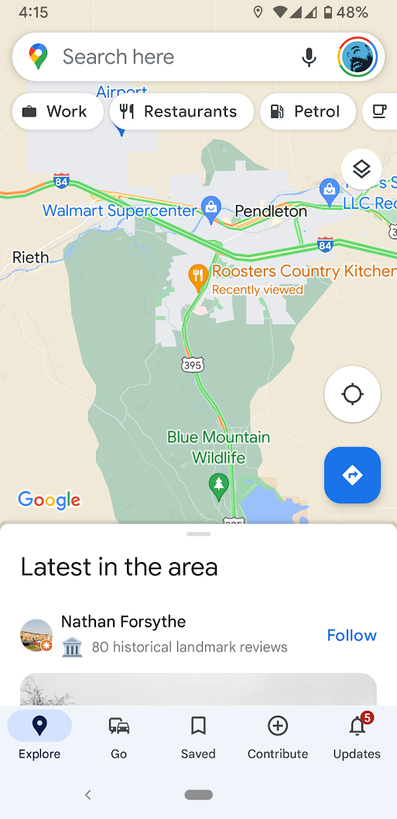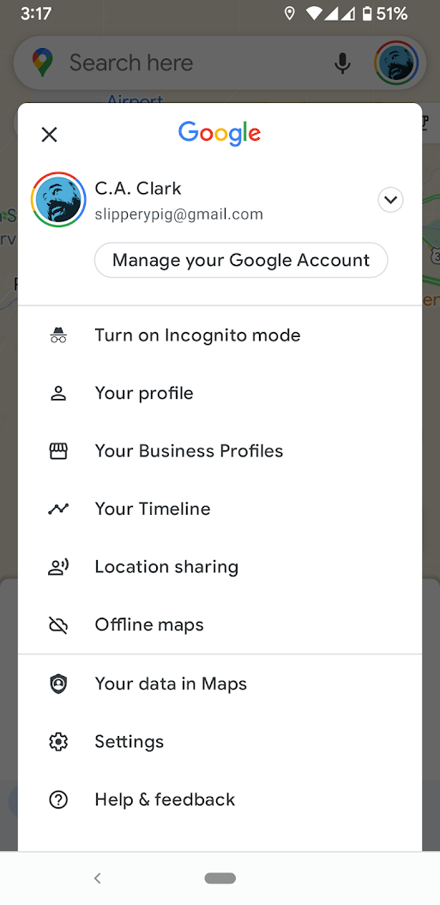

Thirdly, you can access the “desktop” GBP portal via: <https://business.google.com>

If you have multiple locations, it’s possible to add all of those as separate locations under one main account. You’d just repeat the verification steps for each location while logged into your account. While Google has indicated that the business.google.com interface will remain, it will be prioritized for businesses with multiple listings to manage.

**Profile Completeness**

## NAP TIME

Sadly, this isn't the part where we all put our heads down and catch a quick 15 minutes of shut-eye. NAP in this case is short for **Name**, **Address** and **Phone Number**, which are three of the most important items you have in your business listing on Google. Further, keeping these three pieces of information consistent across ALL online platforms is critical for Search Engine Optimization (SEO). Ensure that your Name, Address and Phone are always correct within your Google Profile and use the exact same information in other online listings wherever possible.

CATEGORY CHOICES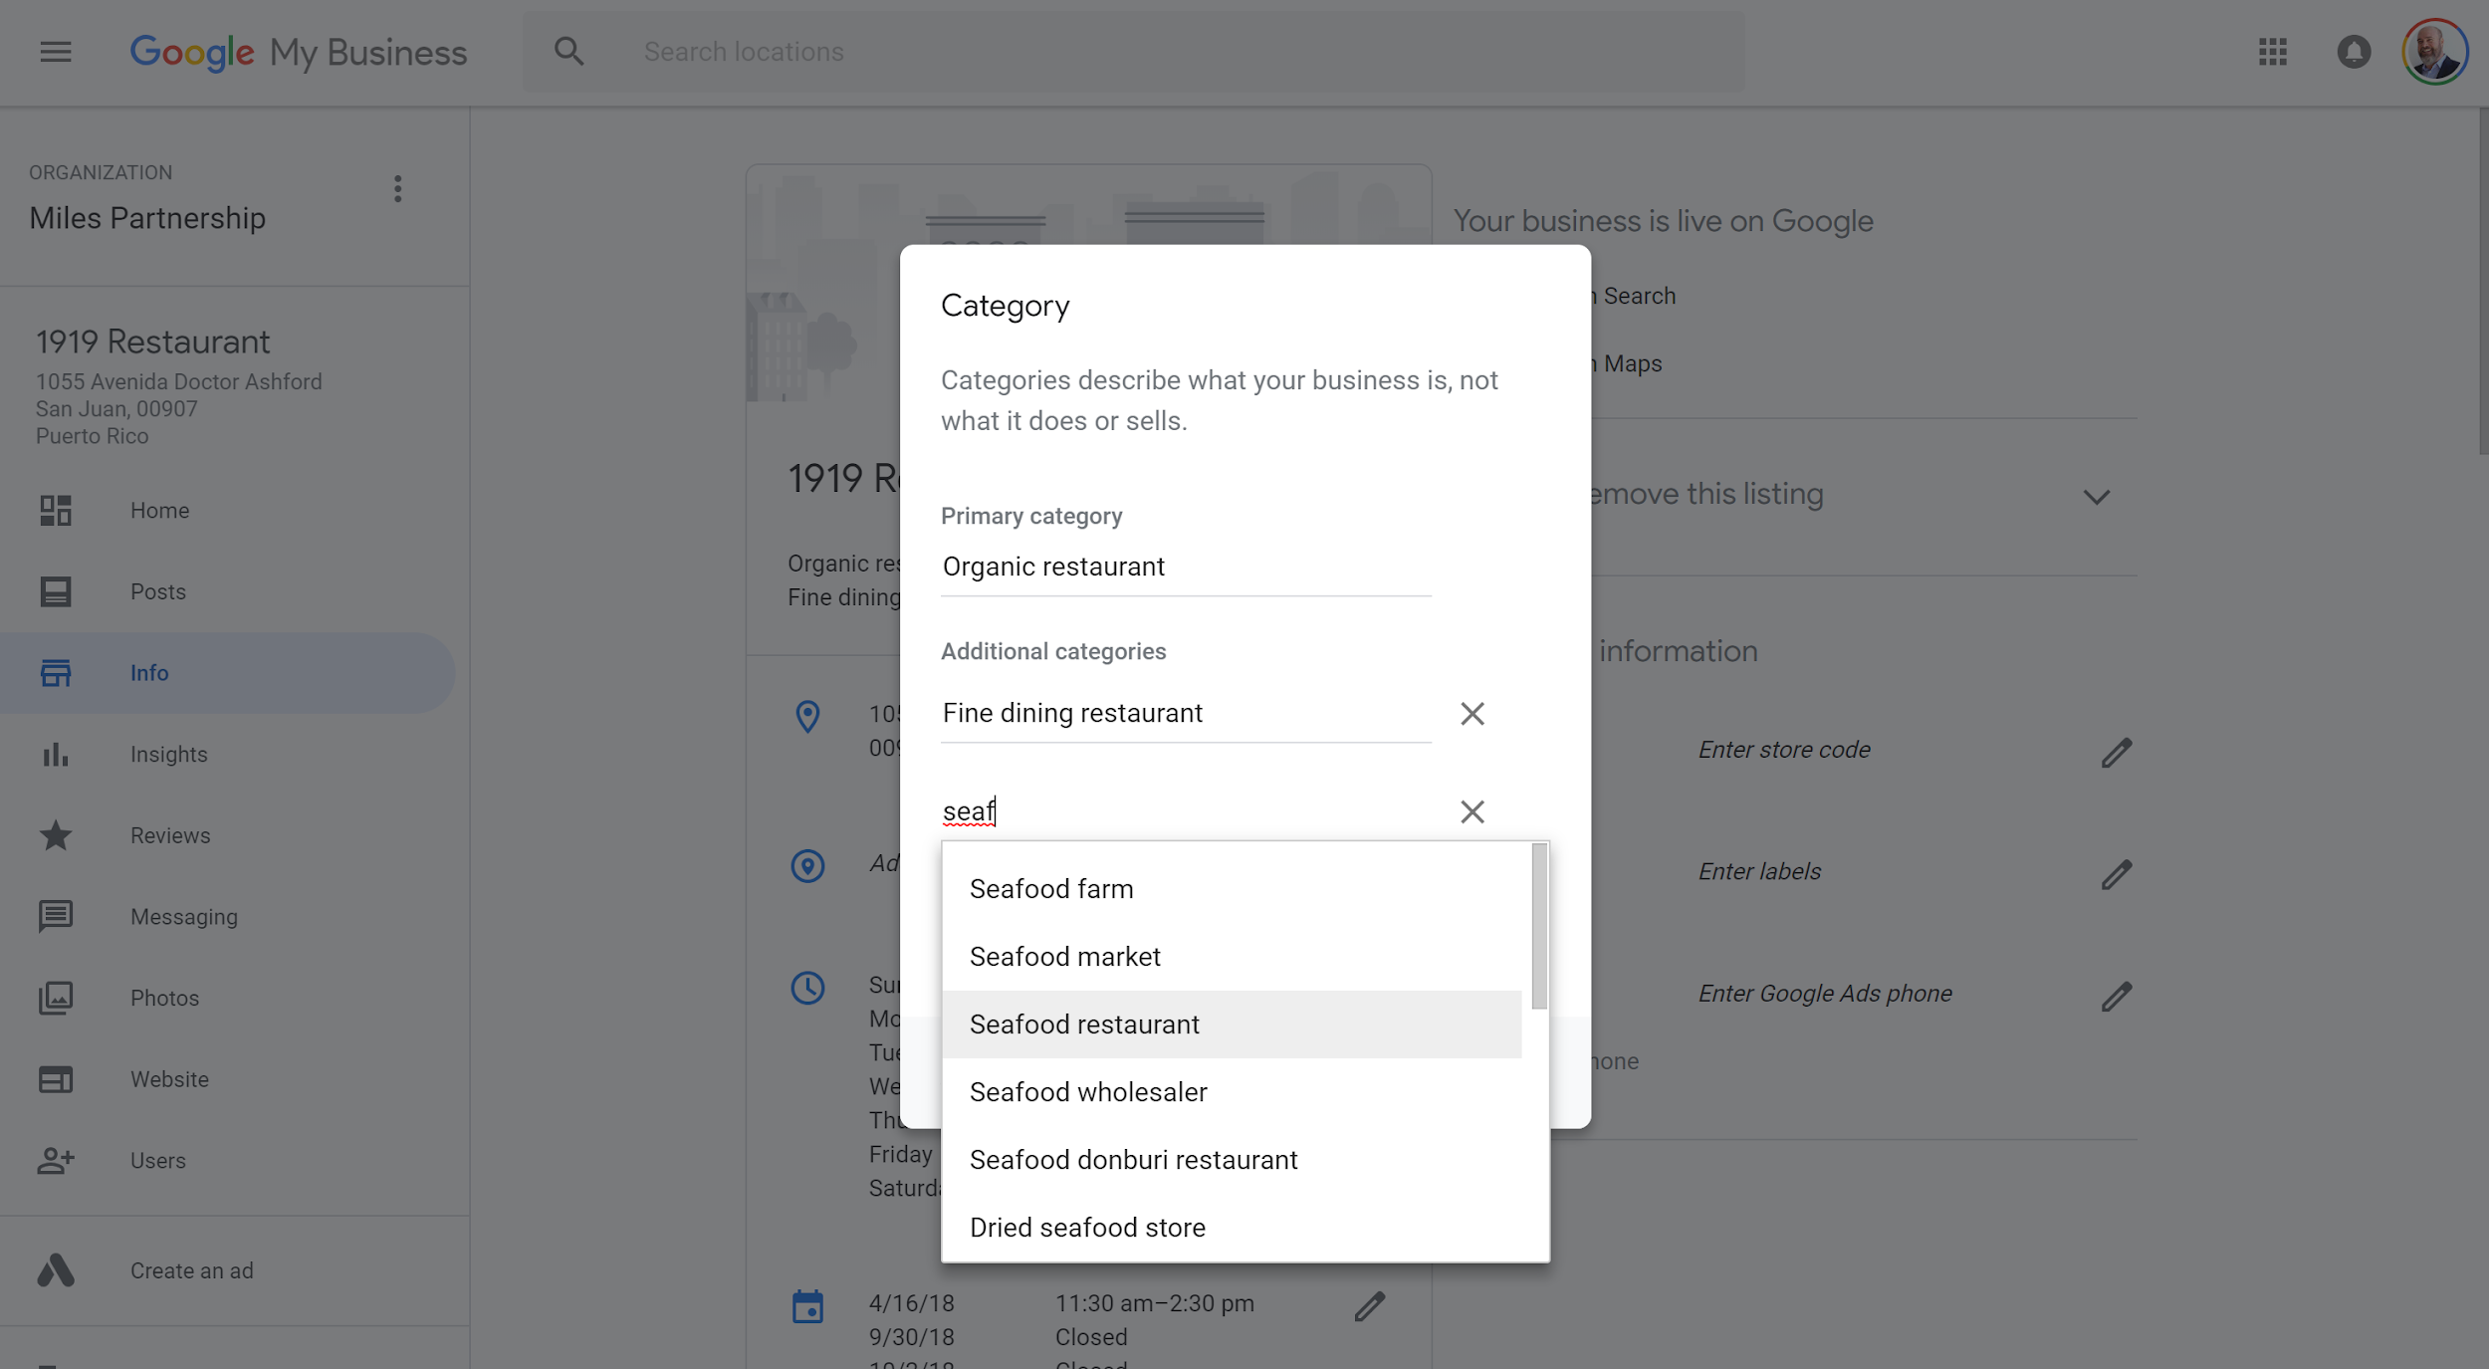

You will need to choose from a pre-existing category from Google's list (there are more than 3,000 categories available, so there should be something that works for you). Aim for the one that is most accurate, if your specific niche isn't included. You’re allowed to select up to ten categories for your business. One primary category and nine additional categories.

## 

## HOURS

Business hours is another data point that seems easy to skip, but is actually really important. Listing your business hours isn't just important because people are very likely to be searching for your business to find out whether you are open or not (although that is one reason why they matter). According to Google's search data, there's been a 300% increase over the last two years for searches involving businesses "open now." The results for those searches will only include businesses that have hours included because those are the ones it can confirm are open.

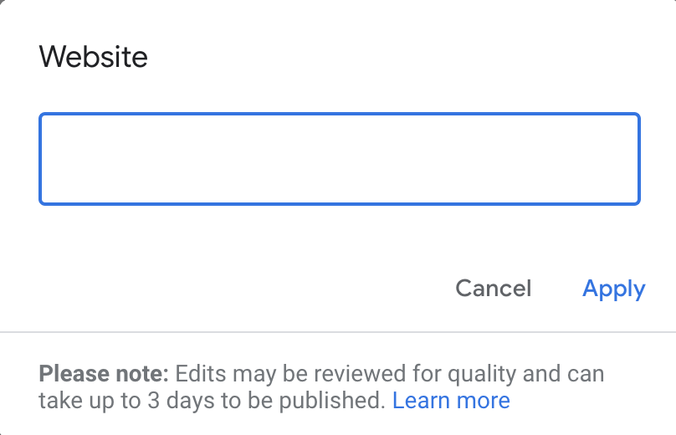

## WEBSITE

Of course it's important to have a link to your website included for your business listing. This doesn't just appear in search results. The information also appears across a range of different Google products, including Maps, the Things to Do page, and many more.

## DESCRIPTION

The business description is a great opportunity to showcase the unique aspects of your business and differentiate yourself from your competition. The description was made available to verified businesses (except hotels and a few other categories) in 2018 after several years of being unavailable.

### 

### Tips for Writing a Good Description

One key to writing a great description is to show people why you're special rather than telling them that you are special. That sounds simple, perhaps, but it's among the most common mistakes businesses make in [copywriting](https://newmexico.tourismbusinessmarketing.com/copywriting-for-the-web-part-1). Every place says it’s the best (like the scene in *Elf* when Will Farrell's character goes in and congratulates the random diner about their sign "World's Best Coffee.") But there's a big difference between saying you're a cafe with the best scones compared to explaining to a potential customer that you spent three years testing different scone recipes to find the perfect one. Obviously that's an extreme example,but it will be more effective to explain the why and how of your unique value proposition rather than just trying to tell people that you are great.

**Listings for Service Area Businesses**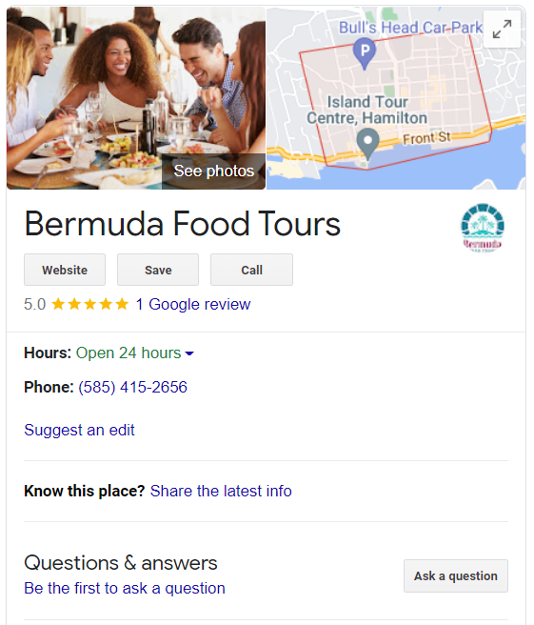

Local businesses may not serve their customers from a brick-and-mortar storefront. Some may operate from a home address or be mobile and don't have a shop front that customers visit. If you have a business that serves customers at their own homes or locations, you should list it as a Service Area Business on Google. Your business will appear in Google SERPs for local search, but may not display a physical address. The radius indicates the area your business serves and can be dictated by city boundaries, zip codes or miles from your business.

ADDING A SERVICE AREA BUSINESS

Sign in to your existing Google account and navigate to [google.com/business](http://google.com/business). Click the green “Start Now” icon to add your business. Enter in the Business Name (As you type, suggestions will start to appear—if you see your business, click to select. If it’s not your business, ignore the drop downs and continue providing your business information.)

1. Add the Country and Full Address as shown on the right. You also need to include the business phone number, business category, and website.
2. As a **Service-Area Business**, select “Yes” to “I deliver goods and services to customers at their location.”
3. Click “Continue.” A pop-up will ask you to confirm your business delivers goods and services and will ask the area your business serves. You can enter named neighborhoods, regions, cities, counties, states and countries as your service areas, you can add multiple but best practice is to keep the total to less than 10. Select if you also serve customers at your business address.
4. To submit, click “Continue.” A pop-up will ask you to verify that you are authorized to manage this business.

EDITING OR REMOVING A SERVICE AREA BUSINESS

Sign in to your Google Business Profile account. On the left side of the screen, click “Businesses” and select the location you want to manage. Click “Info” at the top of the page and follow one of the prompts below.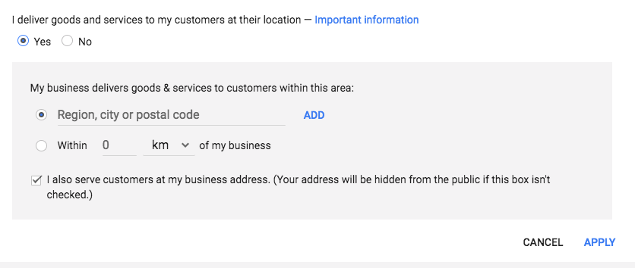

* **EDITING A SERVICE-AREA BUSINESS**: Click the “Address” section. A pop-up will appear prompting you to select **Yes** next to "I deliver goods and services to my customers at their locations." Enter your service area information. You can set your service area based on the zip codes or cities that you serve, or on a given area around your location. Select the box next to “I serve customers at my business address” if you want your complete address to appear on Google and show you also serve customers from your business location. Click “Apply.”
* **REMOVING A SERVICE-AREA BUSINESS**: On the left side of the screen, click the field that lists your service area. In the window that appears, find "I deliver goods and services to my customers at their location.'' Immediately under it, click the “No” button. Click “Apply.”

**Reviews Management & Best Practices**

Google Business Profiles allow you to see the reviews of your business that users have created on Google. Within Google Business Profiles, you have the ability to respond to reviews directly or flag something that may be inappropriate.

WHY REVIEWS ARE IMPORTANT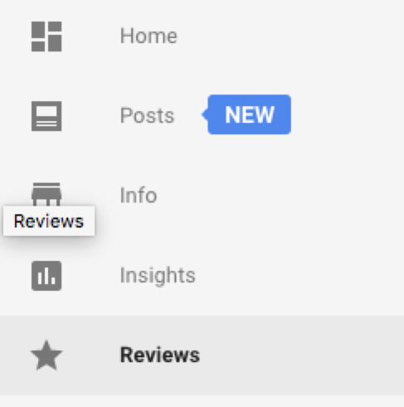

Reviews from customers provide valuable feedback about a business to the owner and other customers. Many consumers decide whether or not to engage with a business based on reviews left by previous customers. 57% of customers will only consider using a business if it has 4 or more stars, according to BrightLocal’s 2022 Consumer Review Survey. Positive reviews and interactions can help set your business apart from competitors. The quantity and quality of reviews are also an important ranking signal for your business in Google. Having a high volume of positive reviews can improve the discoverability of your business within Google products. Likewise, having few reviews (or no recent reviews) can limit your visibility.

HOW TO RESPOND TO A REVIEW

Sign in to your Google Business Profile account. If you have more than one location, select the location you’d like to manage. Click “Reviews” from the menu on the left. Locate the review you would like to respond to and click “Respond.” Once you’ve written your response, click “Submit” and it will be posted.

Responses should be concise and cordial. You want to avoid getting personal when responding to a review because responses are public and remain visible on the business’s Knowledge Panel. Try to keep your responses helpful, clear, and courteous. Remember to thank your reviewers, since each response can reach many customers. You don’t need to include incentives or advertisements. Reviewers are already your customers. Instead, you could tell them something new about your business or share something they may not have been aware of on their previous visit. Responding to reviews encourages your customers to post additional reviews.

RESPONDING TO NEGATIVE REVIEWS

When responding to negative reviews, keep your message short - “so sorry you had a bad experience, we would like to try to resolve this to your satisfaction, please contact us in store or via phone or email.” If you’re able to resolve the issue you can politely ask them to revise their review - even a jump from 1 to 3 is a significant increase and will lessen the impact. It’s highly unlikely you’ll hear from the reviewer - but responding to their negative review does two things. One: because 1 star reviews have a lot of weight in a rating system that is essentially between 4.1 and 4.9 it’s worth a shot even if it’s unlikely. Two: it shows that you care about customers and their concerns - which in some ways can be more valuable than not having the review in the first place. *Note that you are prohibited from offering incentives for reviews including for revising a negative review.*

REQUESTING TO REMOVE A REVIEW

Before flagging a review, you should familiarize yourself with Google’s policy for reporting reviews. You shouldn’t flag a review because you don’t like it. To flag a review in your account, sign in to your Google Business Profile account. On the left side of the screen, click “Businesses” and select the location you want to manage. Click “Reviews” from the menu. Find the review you want to flag, and click the three-dot menu to the right of the review, then select “Flag as inappropriate.” You can also flag a review from Maps. Navigate to Google Maps and find your business listing. Find the review you want to remove and click the three-dot menu, and “Report review.”  
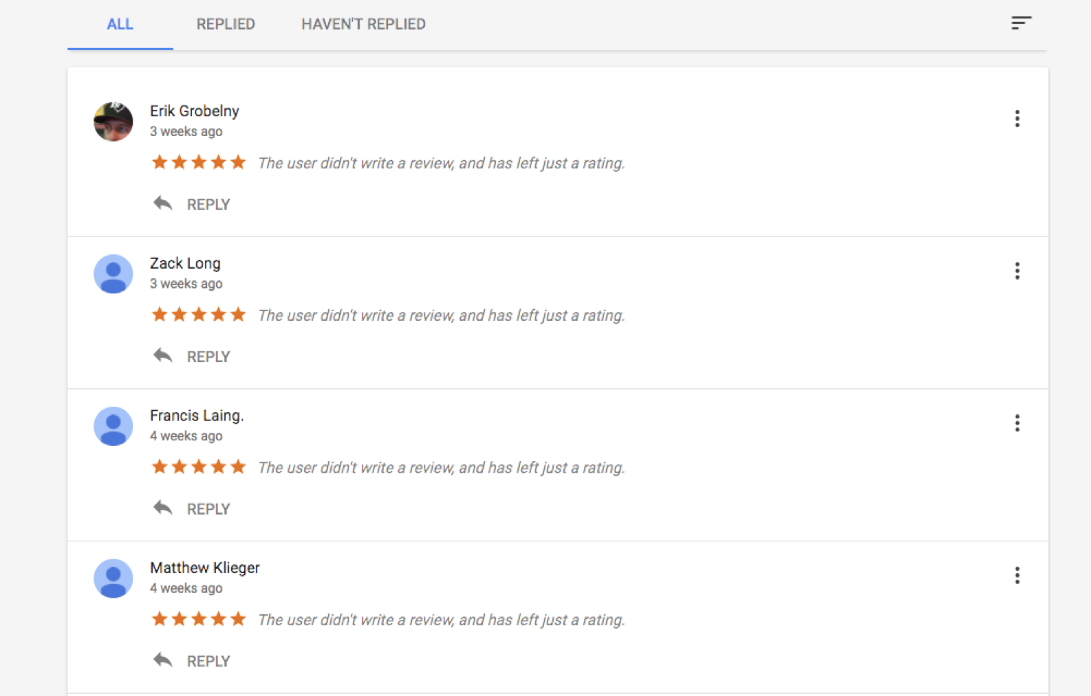

WHY A REVIEW CAN BE REMOVED

A review can be removed for various reasons. Reviews should not be used as advertisements. If a review has links to other websites or phone numbers, it can be removed. Reviews from multiple accounts with the same content are considered spam. If a review is off-topic or is based on someone else’s experience, the review can be flagged. Reviews are not meant for political or social commentary or personal rants. A review should be honest and unbiased. Reviews should not come from the business owner or employees of the business and should not be on behalf of others. If a review has inappropriate content it can be flagged for removal: illegal or copyrighted content, sexually explicit material, personal and confidential information, or hate speech.

**Photo Management & Best Practices**

Managing images of a business can have a significant impact on the quality of content users find when researching travel online. It is possible to add or remove photos from your account at any time. There are also ways to flag inappropriate images added by other users.

ADDING IMAGES OF YOUR BUSINESS

Data from Google shows that businesses with high-quality, relevant images receive higher levels of engagement from users and are more likely to be visited by consumers who have viewed that business listing online. Having photography that includes the exterior and interior of your location as well as photos of products or services available can be beneficial to attracting customers.

To add an image or images, simply log into your Google Business Profile account and select the “Photos” tab from the menu bar on the left side of the screen. From this section, you’ll be able to add and manage images, including selecting the cover image, identifying specific subjects (such as food photos for a restaurant) and other actions. You can add photos from your device or from Google Photos.

HOW TO REMOVE AN IMAGE FROM YOUR LISTING

**Removing an Image Added to Your Account**

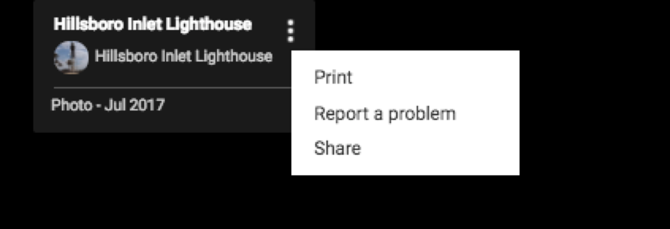Sign into your Google Business Profile account and choose the listing you’d like to manage. Select “Photos” from the menu on the left. Click the image you want to remove and then click the trash can icon in the top-right corner. This will delete the image from your listing.

**Flagging Images from Other Users for Removal**

To flag an image from another user for removal, navigate to your location’s photo gallery in Google Maps. Click on a photo to pull up the photo gallery image panel, and click on the three-dot menu icon in the top left corner. Select “Report a Problem.” Complete the information on the form about why the photo should be flagged and then click “Submit.”

**A photo must be in violation of Google’s photo policy in order to be removed.** Sometimes it is necessary to flag an image a second time, if it is not removed after an initial period of 7-14 days.

PHOTO BEST PRACTICES

**Photo Orientation**

Orientation is important for photo selection, and it’s best to keep this in mind when photographing a location. Horizontal images are preferred. Vertical images are acceptable if they have sufficient resolution to be cropped horizontally. Avoid using extreme angles or tight crops on images. For example, when photographing a building’s exterior, try to find a direct shot that includes as much of the façade as possible. When shooting food or small details, it may be more practical to use an overhead angle or a close crop.



**Clarity**

The location should be the focal point of the photo. Users should be able to easily recognize what they are seeing. Photos should be sharply focused and without blurriness. Images should look real and be high-quality without being heavily doctored.

**Lighting**

You want to add images that showcase the focal point in the best manner possible, including quality lighting. It’s generally a best practice to capture things during the day, unless you are highlighting a location specifically known for its nightlife. Subtle differences in lighting quality can make notable differences in visibility of photos within Google products.

**Color**

Choose images that have bright, vibrant colors because these often generate better visibility and more engagement. Your image may be competing against hundreds of other photos of a given location for a customer’s attention. While photos should not be heavily doctored, modestly boosting the saturation of images may be beneficial in some cases.

**Seasonality**

As much as possible, images should be relevant year-round. This means avoiding seasonal photos (e.g. holiday decorations or colorful fall shots). However, seasonal shots may be utilized if the location is season-specific such as “U-Picks” or ski slopes.

**Photo Rights and Watermark**

When adding photos, you want to avoid intellectual property violations. Make sure the photos you are uploading belong to you. Try to add a variety of unique images rather than uploading the same images repeatedly. If your photos have a watermark, it should be small and limited to one corner to avoid distracting from the overall image. Photos should never include inappropriate or dangerous content, including child endangerment, harassment or threats, and personal or confidential information. Photos should not be an invasion of privacy.

**How to Use Posts in Google Business Profiles**

Posts allow a business to share information about sales, promotions, upcoming events, announcements, or new products directly on the business’s Knowledge Panel in search and map results. These function as a relatively simple and fast way to deliver content directly to users searching for your business. You can access and manage Posts via your Google Business Profile account.

CREATING A POST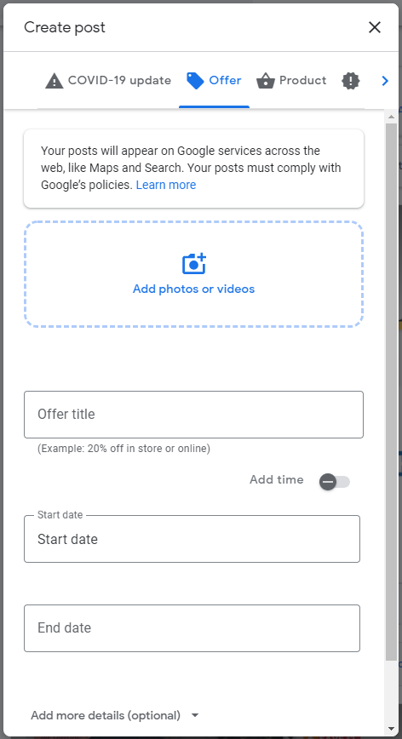

Sign in to your Google Business Profile Dashboard. On the left side of the screen, click “Businesses” and select the location you want to manage.

On the dashboard on the left, select “Posts,” click on the type of post that you would like to make, and a Post box will appear for you to add the information. A complete post includes an image, brief copy, a call to action for users, and potentially additional information depending on the type of post.

EDITING OR REMOVING A POST

You can edit or delete a post at any time. To edit or remove a post, click on the post you want to edit or remove and click “Edit” or “Delete” as appropriate. If applicable, preview your edits and “Publish” in the top right corner of the screen.

HELPFUL INFORMATION ON POSTS

* You can add a call to action for users to further engage or find more information. These include: Learn more, Reserve, Sign up, Buy, or Get offer. The call to action can be linked to content on your website.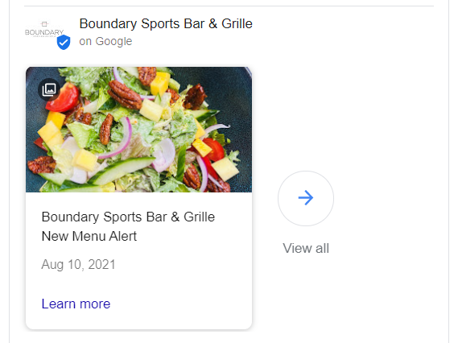
* You can preview the post before you publish by clicking “Preview” in the top right corner. If you are satisfied with the post, click “Publish” and the post will be visible to the public.
* If you have multiple posts, the newest ones will show first, and the older ones will show in a carousel format. Google will scroll up to 10 posts in the carousel but only the first two are shown on search results pages.
* The posts have unique URLs and can be shared by customers or linked to from other online platforms including your website.

TIPS AND BEST PRACTICES FOR POSTS

**Content**

Posts should be brief, helpful, and encourage action. Before creating a post, it’s best to determine what the goal of the post is and the message you want to deliver. It may be encouraging a customer to navigate to a sale on your site or announcing a new product. You want to avoid using gimmicky language or excessive punctuation as Google forbids it, and your post may be removed. You want to have a complete post include as much information as possible. This includes a catchy but concise title. There is a limit of 58 characters in the title.

**Photos**

Photos should be well-lit, clear and high-quality. The minimum resolution is 720px wide by 540px tall, in JPG or PNG format. Images should have a central focal point to avoid awkward cropping and reinforce your post. When adding photos, you want to avoid intellectual property violations so do not use photos that do not belong to you. Try to add a variety of unique images rather than uploading the same images repeatedly.

**Take your Google Business Profile to the next level with Locl**

You already know your Google Business Profile (GBP) is a significant source of organic exposure for your business. It’s the first thing potential customers see when searching locally. But GBP is also a rapidly changing platform, which can be hard to keep up with.

TOOLS TO MAKE MANAGING GBP EASIER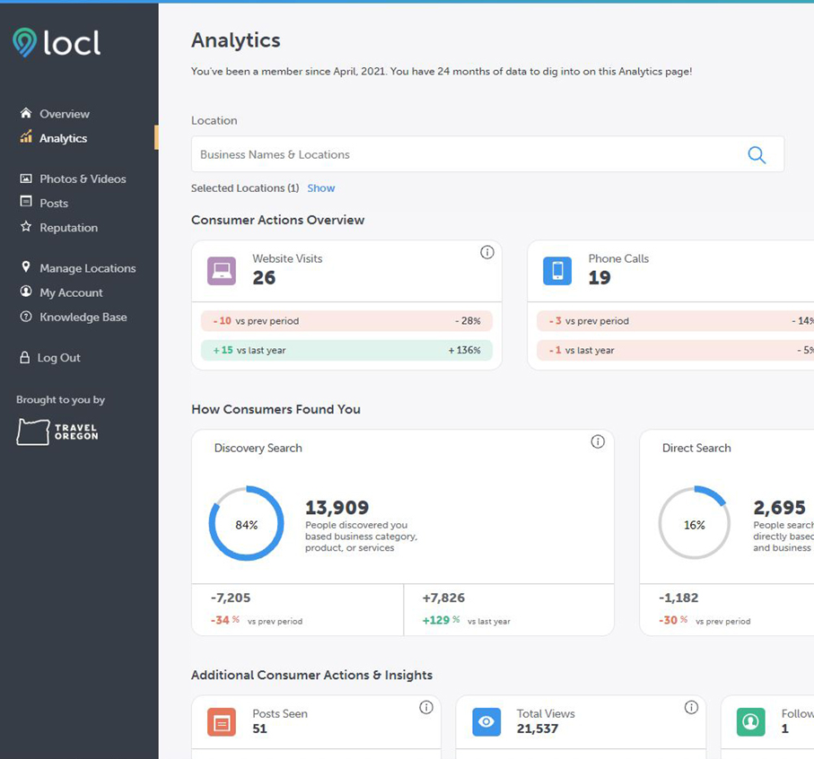

Travel Oregon has teamed up with Oregon-based company, Locl, to make managing your Google Business Profile simple and fast. Through this partnership, Oregon tourism businesses can get access to Locl’s easy-to-use tools and business performance insights for **free**.

LOCL FEATURES

Locl’s suite of Google Business Profile optimization tools helps you prioritize and manage your profile with less hassle. With recommendations, intuitive tools and answers your questions, Locl takes the guesswork out of how and where to focus your time.

Here are a few key features you’ll get access to through this exclusive partnership:

* One handy dashboard to manage your listing or group of listings
* Alerts on Smart To-Do’s
* Customer Reviews Center
* Manage your posts, offers and events
* Timely emails with actionable tips and recommendations
* View up to 18+ months of analytics data
* Access real-person support

SIGN UP FOR LOCL

The whole sign up process takes just a couple of minutes and is free for Oregon tourism businesses. Sign up for Locl here: <https://locl.io/traveloregon> or learn more about the program at <https://industry.traveloregon.com/locl>.